- Click on SAT registrations in blue on the left.

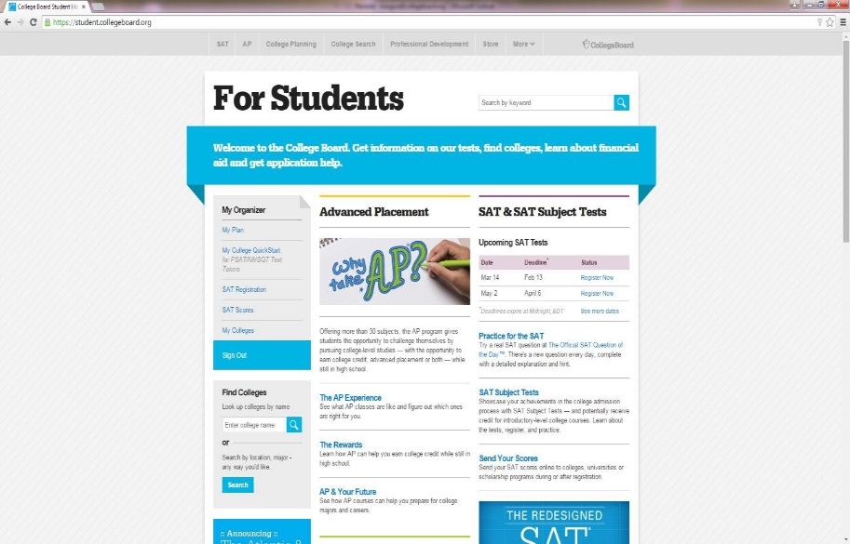

- Click “Register Now” under SAT Registrations:
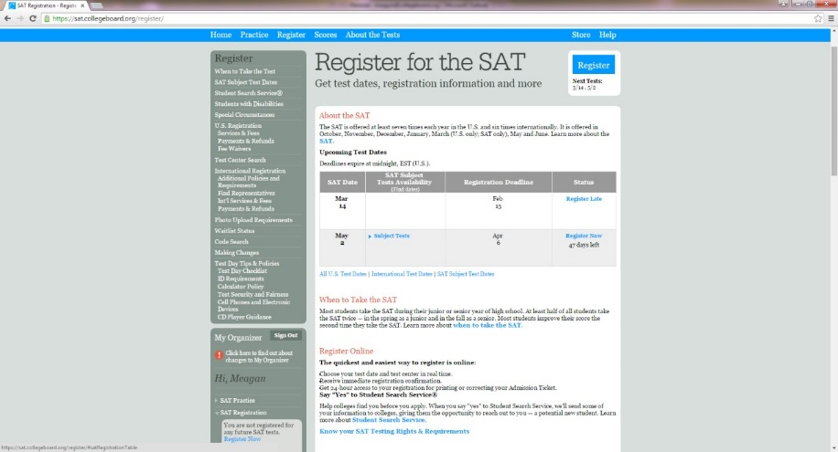

- Re-enter your password.

- Once the security check point is validated, you will be taken to the page below. If you see the March 2 test date listed, then your account is already linked and you can add schools to receive scores once they are available. If the March 2 test date is NOT listed please see step 5.
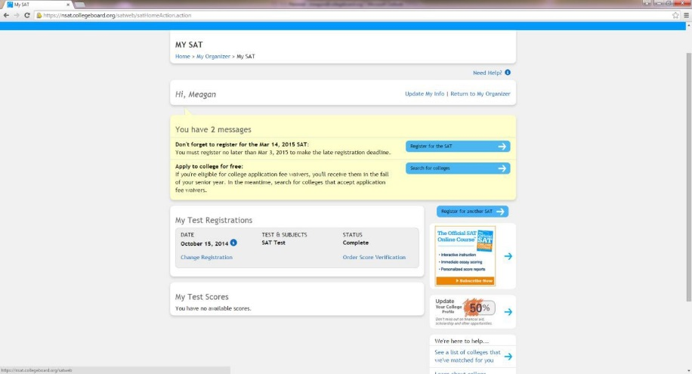

- If the March 2 test date is NOT listed please click on the blue box to the right of the screen above that says, “Register for another SAT”

  - Students will then be taken to the page below. They will select “Let’s Go”

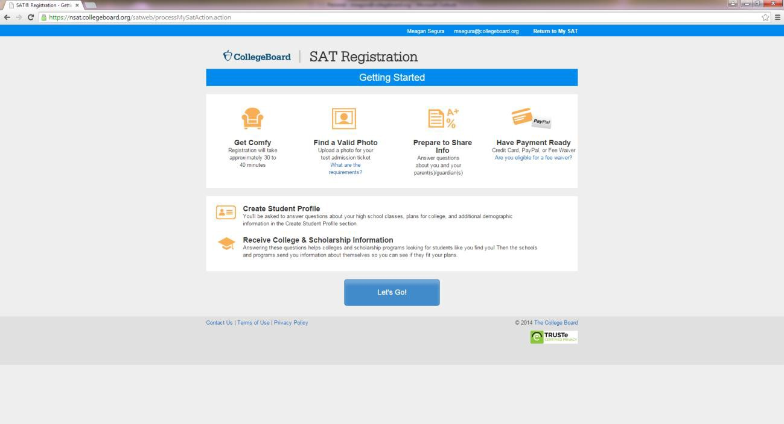

  - Enter in your March 2 School Day registration number that is listed on your white notecard. After completing all required fields on this page and selecting “Continue” at the very bottom, you should be able to successfully view their March 2 SAT Registration!

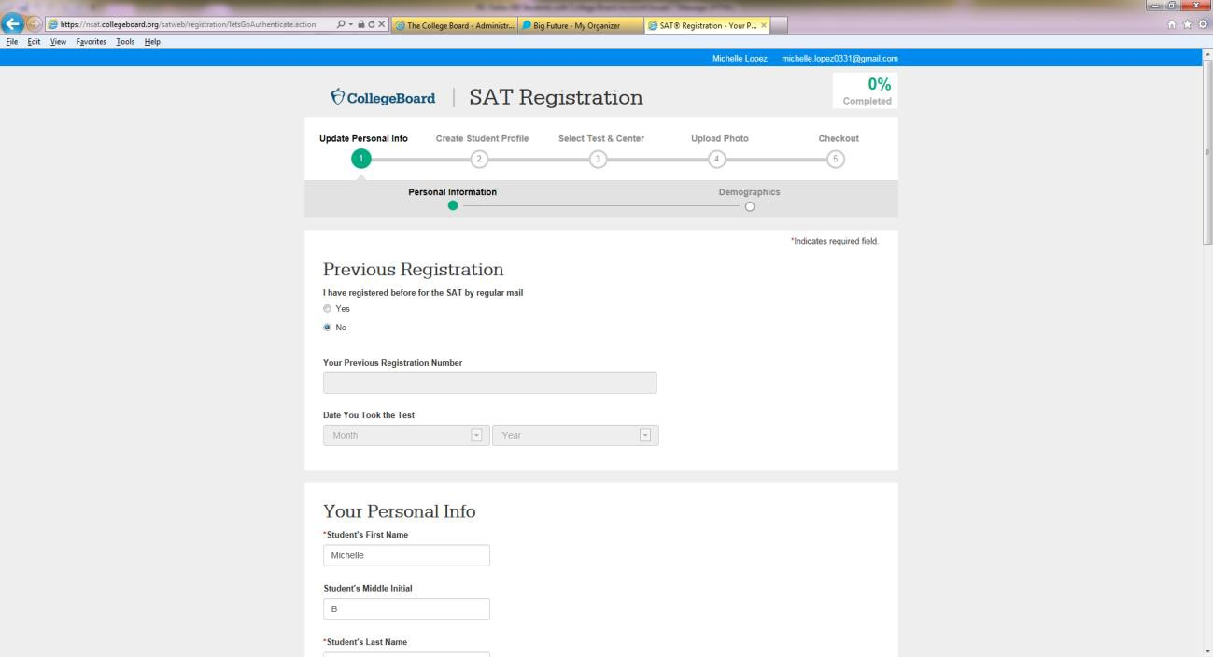

THE END!

